1.17

My code takes the int max and originally sets it to a. It then tests a against b and c to solve what the max is. The code with a 4th int is the same.



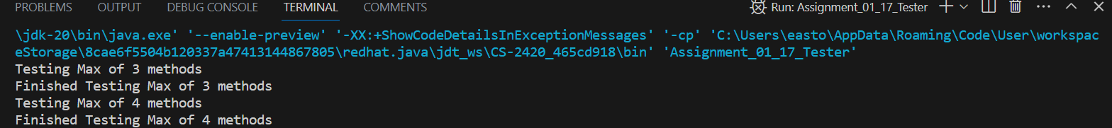

Problem 1.20



My code just test divides the number first and if it succeeds with dividing and getting a result over 0, it adds a letter to the string and subtracts the number so we do not repeat. This continues until the number gets to 0.

